Running Head: Perception

Depth Perception

Ray Thomas
Ivy Tech State College
PSY 101 – 12G
July 2003
Abstract

Depth perception is an important advantage for humans and other binocular animals. Not only does it give us an accurate sense of where objects are in relation to one another but also where we stand in relation to those same objects. Although there are monocular clues to depth perception, our binocular vision makes coordination between hand and eye much more accurate. A third of our brain is devoted to vision in one form or another. This paper will show how our brain uses the clues given by our eyes to produce an accurate view of the world that surrounds us.

Most mammals and some other groups of animals can be divided into two classes; the browsers and the hunters. Hunters have forward facing eyes. The extra information relayed to the brain from having two overlapping images from the eyes give extra clues to how far away prey or any other object is. Browsers need good all round vision to detect a threat. This is why cows, sheep and horses have eyes situated on the sides of their heads. This does not mean they lack depth perception. There are good monocular clues as to the relative positions of objects. It’s just that binocular vision is better.
At birth, babies have poor eyesight. They are unable to focus properly and the eyes are sometimes completely uncoordinated. This is because although they have the physical structures in order to see, they haven’t learned to use them yet. At two months they are starting the process of turning the individual images seen by their eyes into a single image. At five months, full binocular vision is achieved. They can see in full color and have learned to like some colors above others. They can now also focus on objects farther away and can pick up objects. But it isn’t until they are around six months old that they begin to have depth perception. It may take a further four years until the brain can process the information it receives from the eyes accurately enough to have full depth perception. (CVIN; Lucile)
The now famous “Visual Cliff” experiments of the 1960’s by Eleanor Gibson and Richard Walk showed that babies six months old would not venture over a drop covered by glass. (Gibson & Walk, 1960) More recent studies have shown that this isn’t the whole story. Babies over nine months old placed on the glass covered drop have an increased heart rate, perhaps showing that they are frightened. Babies less than six months old actually show a decreased heart rate. Other experiments show that the sight of their smiling mother on the other side of the drop will encourage the toddlers move across it, overriding their fear. (Talaris, 2002)
The brain takes the information received from the eyes and combines it into a single image in a process called stereopsis. The result of this can be seen in Figure 1. There are believed to be around thirty areas in the brain used to process visual information, taking one third of the brain. Researchers using Magnetic Resonance Imaging (MRI) at Massachusetts General Hospital have so far identified fifteen of them. (Mapping Vision, 1995) Information from the eyes is sent along the optic nerves. In an area called the Optic Chiasm, the nerves join and then separate. At this junction, information from the left eye is now sent to the right side of the brain and vica versa. The signals now travel to an area in the thalamus called the lateral geniculate nucleus (LGN). This appears to be a relay station that amplifies the visual signal before transmitting it to the temporal lobes. (Montgomery) Research done at the California Institute of Technology, shows that the temporal lobes are used for extracting motion clues from what we are seeing along with some other visual perception. (Anderson, 1998) The primary visual cortex, located in the occipital lobes, is responsible for most of our visual processing.

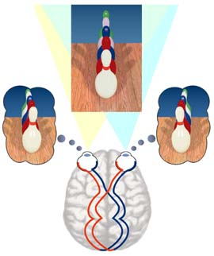
Figure 1. Stereopsis
Images from the eyes are combined into one stereoscopic image.

Optometrists Network, Stereo Vision. Retrieved June13, 2003, from http://www.vision3d.com/stereo.html

See text on page 4

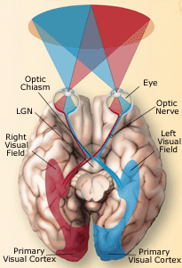
Figure 2. Visual path through the brain

Montgomery, G. Howard Hughes Medical Institute, The urgent need to use both eyes. Retrieved June, 13, 2003 from http://www.hhmi.org/senses/b220.html

See text on page 4

There are many monocular clues for depth perception, all of which give the brain clues as to where an object is in relation to another.
Linear perspective is the apparent convergence of linear lines; for example, a road or railway tracks leading towards the horizon. (Figure 3) It was during the fifteenth century that linear perspective was used in western art. Pictures previous to this lacked “depth” and looked flat or distorted. (Figure 4) This is exactly how we would perceive the world without linear perspective depth clues. Linear perspective is used in conjunction with other monocular clues such as size consistency and relative height.
Size consistency stems from the fact that objects do not usually change size over short periods of time. Thus for an object that we are familiar with, the larger it appears, the closer to us it is. (Figure 5) Mistakes can be made. Clouds, for example, can be any shape and size, and so the distance they are away from us is hard to judge. (Mayer, 2003) Other mistakes can happen. Trains are something that, although we have a passing familiarity with, most people don’t realize just how big they are. (Kardas, 2003) As a consequence we can’t judge their speed very accurately and this gives rise to around 3,000 accidents in the United States annually. (Fry, 2000)
Relative height is the phenomenon where objects furthest away are higher in our visual field. For airborne objects, such as clouds, the reverse is true. Those furthest away are lower in our visual field. In general, it can be said that the closer to the level of the horizon, the farther away an object appears. (Krantz, 2003) This is illustrated in Figure 3.

Figure 3 Linear Perspective
Rock, Irvin, Perception, (page 19) New York: Scientific American Library
(see text on pages 6 and 9)


Figure 4. Art without perspective – the Bateaux Tapestry (circa 1066)
Thomas, Ray. 2003, Bristol, A History and Guide, (1995 – 2003) Retrieved July 19, 2003 from http://brisray.com/bristol/bnames.htm (see text on page 6)
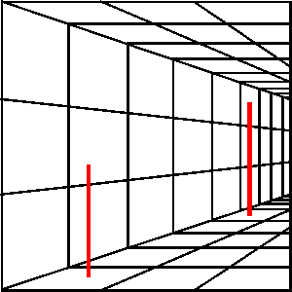
Figure 5.
Perspective and Size Consistency
The two vertical red bars are actually exactly the same size

Thomas, Ray. (1995 – 2003) Optical Illusions, Can you believe your eyes? Retrieved July 19, 2003 from http://brisray.com/optill/oeyes1.htm

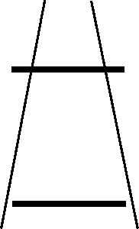
Figure 6.
Ponzo Illusion
The horizontal bars are actually exactly the same
size.

Thomas, Ray. (1995 – 2003) Optical Illusions, Can
you believe your eyes? Retrieved July 19, 2003 from
http://brisray.com/optill/oeyes1.htm

(See text on page 6)

Texture Gradient is another monocular clue. The closer something is to us, the more detail and texture can be seen. As the distance increases the amount of texture lessens until it looks uniform. (Gibson, 1950) This is illustrated in the receding pattern of crops in Figure 3.
Aerial or Atmospheric perspective is caused by the scattering of light in the atmosphere by small particles or vapor. Blue light, which has a shorter wavelength than other colors, is scattered more than the other colors. This scattering causes distant objects to appear slightly hazy and bluish in color. This is also why mountains appear much closer on clear, dry days. (Figure 7)
Light, shadow, shading and brightness, and color consistency play an important part in our perception of objects. We are used to objects being lit from above and we use this to define the depth and shape of them. (Figures 8 & 9) We are also usually very good at judging the color of objects. A piece of coal, for example, may reflect ten times as much light as snow in shade, making it appear very much brighter. But we can still tell what color it is. (Mayor, 2003) Some experimenters have found that when the brightness of a surface is kept constant, but the illumination of the surrounding area is varied then people think the brightness of the test surface also varied. (Wallach, 1948) (Figure 10) We are used to viewing objects in a certain way. When a hollow face mask is viewed, the brain has great difficulty in presenting an inside-out face and we persist in seeing a normal view of the face. (Gregory, 1970)(Figure 11)
Occlusion or interposition is the overlapping of one object by another. If an object overlaps another object we know that object is closer than the object it is overlapping.

Figure 7 Aerial or Atmospheric Perspective
Light is scattered by the atmosphere therefore distant objects seem hazy and bluish.

Kolb, Helga; Fernandez , Eduardo & Nelson, Ralph (2003), The Perception of Depth, Webvision, Retrieved July 19, 2003 from http://retina.umh.es/Webvision/KallDepth.html
(see text page 9)

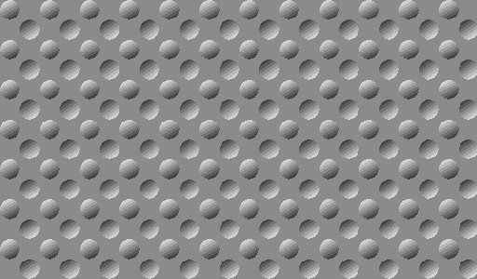
Figure 8 Bumps
The perceived 3D effect in a two dimensional medium by the use of light and shading.

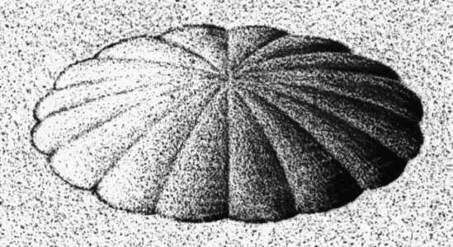
Figure 9 Vexcav Is this image convex or concave?

Thomas, Ray. (1995 – 2003) Optical Illusions, Can you believe your eyes? Retrieved July 19, 2003 from http://brisray.com/optill/oeyes1.htm (see text page 9)

Figure 10 Shades of grey
The grey color in the middle of these squares is the same shade, yet they appear different because of the surrounding color.
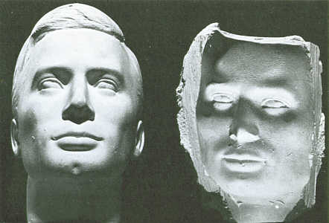
Figure 11 Face moulds
The figure on the right is actually the rear of the one on the left and is convex

Thomas, Ray. (1995 – 2003) Optical Illusions, Can you believe your eyes? Retrieved July 19, 2003 from http://brisray.com/optill/oeyes1.htm and Faces from http://brisray.com/optill/oface1.htm (see text on page 9)
Motion parallax is the apparent motion of objects relative to us. If we are moving or even simply moving our head from side to side, objects that are closer than our fixation point appear to move backwards. Those further way appear to move in the same direction. Objects that are further from away seem to travel more slowly than those nearer us.
Accommodation is the final monocular clue and refers to the change in shape of the eye’s lens to bring an object into focus and the feedback from the muscles we use to bring about that focusing action. Accommodation is practically useless for judging distances of more than three metres (twelve feet) from us but can be very useful for objects within arms reach.
The next set of clues used for depth perception are binocular. These are very much more accurate than the monocular clues.
Related to accommodation is convergence, this is the feedback from the muscles controlling our eyes as they look at the same object. Like accommodation it is only useful for objects up to around three metres (twelve feet) away.
Retinal disparity is the main binocular depth perception clue. Our eyes are around six cm (one and a half inches) apart from each other and because of this, each sees a slightly different view of an object. Our brain is able to combine these two separate images and combine them into a single 3D image. As it does this, it can also extract depth perception clues. The brain is so good at doing this that it can create 3D images where none exist. This is the basis of single image random dot stereograms (SIRDS). The images our brain receives from our eyes are very slightly different. The closer the images are to another the nearer the object they are looking at is. SIRDS make use of this by repeating a pattern of dots, but although the pattern may look the same, there are subtle differences in them. For areas of the 3D image that appear closer to the observer, the dots are very slightly closer together. (Thomas, 2001)(Figure 12) Because SIRDS are designed for eyes that are placed horizontally as soon as the image is turned even a few degrees then the 3D image disappears.
Fusion occurs when the images from the eyes are combined into a single image. Sometimes the image perceived by the brain is so ambiguous that the brain can not decide which is in error, and so it oscillates between the two in what is known as Retinal Rivalry. This ambiguity is used in a great many optical illusions and retinal rivalry is the result. This is why many of these illusions are so confusing. Some of these illusions are designed to contain more than one image, so one person may see one thing and someone else will see a completely different image. (Figures 13 & 14)


Figure 12 A cone as a Single-Image Random Dot Stereogram (SIRDS)
Although made up of a simple repeating pattern of dots a solid 3D cone can be seen
Thomas, Ray, SIRDS - Single Image Random Dot Stereograms, (2001) QBasic Programming. Retrieved July 19, 2003 from http://brisray.com/qbasic/qsirds.htm

(see text page 14)
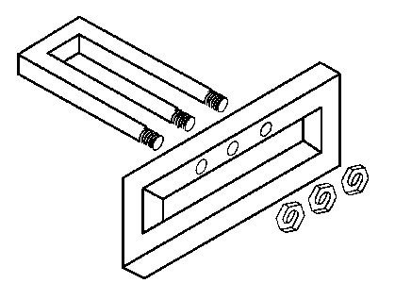
Figure 13 Technical drawing? (see text page 14)
Thomas, Ray. (1995 – 2003) Optical Illusions, Almost Real Retrieved July 19, 2003 from http://brisray.com/optill/oreal.htm
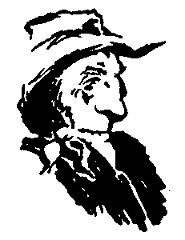
Figure 14 Husband and father-in-law by Jack Botwinick (see text page 14)
Thomas, Ray. (1995 – 2003) Optical Illusions, This or That, Retrieved July 19, 2003 from http://brisray.com/optill/othis.htm

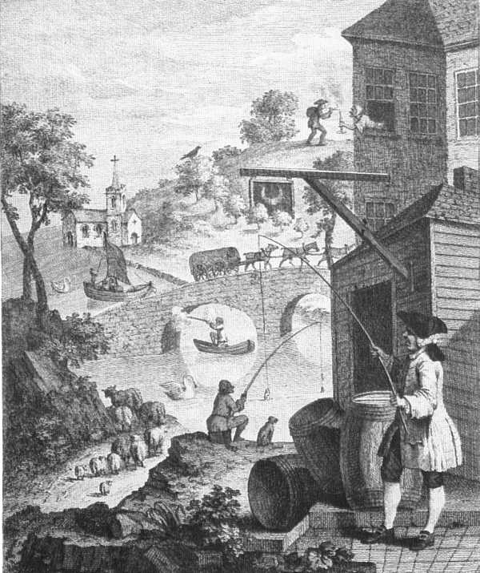
Figure 15 William Hogarth – Perspectival Absurdities (1754)
The frontispiece to J. J. Kirby’s book “Dr. Brook Taylor's method of perspective, made easy, both in theory and practice” Ispwich:1755
References
Anderson, R. Neuroscientists locate area of brain responsible for 3-D vision. CalTechPress Releases. Retrieved June 13, 2003 from http://pr.caltech.edu/media/lead/041698PER.html
Children’s Vision Information Network, Vision Development. Retrieved June 11, 2003 from http://www.childrensvision.com/development.htm
Fry, David, (Jan 2000), No room for complacency on crossings despite fewer accidents, (Jan 2000) Danger Ahead – Historic Train Accidents. Retrieved June 19. 2003 from
http://danger-ahead.railfan.net/reports/rep2000/us_xing_stats20000130.html
Gibson, E. J. & Walk, R. D. (1960). The "Visual Cliff", Scientific American 202, 64-71
Gibson, J. J. (1950), The perception of the visual world. New York: Houghton Mifflin.
Gregory. R. L. (1970), The Intelligent Eye. London: Weidenfeld & Nicolson.
Kardas, Edward P. Motion Parallax, (2003), Southern Arkansas University, General Psychology. Retrieved July 19, 2003 from http://peace.saumag.edu/faculty/Kardas/Courses/GPWeiten/C4SandP/MotParallax.html
Krantz, John H. Relative Height, (Jan. 2003) Hanover College, Psychological Department, Vision and Art. Retrieved July 19, 2003 from http://psych.hanover.edu/Krantz/art/rel_hgt.html
Lucile Packard Children’s Hospital, Growth and Development, Age-Appropriate Vision Milestones. Retrieved June 11, 2003 from http://www.lpch.org/DiseaseHealthInfo/HealthLibrary/growth/visage.html
Mapping Vision. On the Brain, the Harvard Mahoney Neuroscience Institute Letter (Fall 1995, Vol 4, Number 4). Retrieved June 13, 2003 from http://www.med.harvard.edu/publications/On_The_Brain/Volume4/Number4/Map.html
Mayer, Ronald W. Depth Perception and Constancy Phenomena, (April 2003), San Fransisco State University, General Psychology, PSY200. Retrieved July 19, 2003 from http://online.sfsu.edu/~psych200/unit6/66.htm
Montgomery, G. A Hot Spot in the Brain's Motion Pathway, Howard Hughes Medical Institute. Retrieved June 13, 2003, from http://www.hhmi.org/senses/b220.html
Talaris Research Institute, Mommy, is this Ok? (2002). Retrieved June 13, 2003 from http://www.talaris.org/spotlight_mommy.htm
Thomas, Ray, SIRDS - Single Image Random Dot Stereograms, (2001) QBasic Programming. Retrieved July 19, 2003 from http://brisray.com/qbasic/qsirds.htm
Wallach, H. (1948), Brightness Constancy and the Nature of Achromatic Colors, Journal of Experimental Psychology 1948, 38:310-324.
List of Figures
Figure 1. Stereopsis page 5
Optometrists Network, Stereo Vision. Retrieved June13, 2003, from http://www.vision3d.com/stereo.html
Figure 2. Visual path through the brain page 5
Montgomery, G. Howard Hughes Medical Institute, The urgent need to use both eyes. Retrieved June, 13, 2003 from http://www.hhmi.org/senses/b220.html
Figure 3. Linear Perspective page 7
Rock, Irvin, Perception, (page 19) New York: Scientific American Library
Figure 4. Art without perspective page 7
Thomas, Ray. 2003, Bristol, A History and Guide, (1995 – 2003) Retrieved July 19, 2003 from http://brisray.com/bristol/bnames.htm
Figure 5. Perspective and Size Consistency page 8
Thomas, Ray. (1995 – 2003) Can you believe your eyes? Optical Illusions, Retrieved July 19, 2003 from http://brisray.com/optill/oeyes1.htm
Figure 6. Ponzo Illusion page 8
Thomas, Ray. (1995 – 2003) Can you believe your eyes? Optical Illusions, Retrieved July 19, 2003 from http://brisray.com/optill/oeyes1.htm
Figure 7. Aerial or Atmospheric Perspective page 10
Kolb, Helga; Fernandez , Eduardo & Nelson, Ralph (2003), The Perception of Depth, Webvision, Retrieved July 19, 2003 from http://retina.umh.es/Webvision/KallDepth.html
Figure 8. Bumps page 11
Thomas, Ray. (1995 – 2003) Can you believe your eyes? Optical Illusions, Retrieved July 19, 2003 from http://brisray.com/optill/oeyes1.htm
Figure 9. Vexcav page 11
Thomas, Ray. (1995 – 2003) Can you believe your eyes? Optical Illusions, Retrieved July 19, 2003 from http://brisray.com/optill/oeyes1.htm
Figure 10 Shades of grey page 12
Thomas, Ray. (1995 – 2003) Can you believe your eyes? Optical Illusions, Retrieved July 19, 2003 from http://brisray.com/optill/oeyes1.htm
Figure 11 Face moulds page 12
Thomas, Ray. (1995 – 2003) Can you believe your eyes? Optical Illusions, Retrieved July 19, 2003 from http://brisray.com/optill/oeyes1.htm
Figure 12 A cone as a Single-Image Random Dot Stereogram page 15
Thomas, Ray, SIRDS - Single Image Random Dot Stereograms, (2001) QBasic Programming. Retrieved July 19, 2003 from http://brisray.com/qbasic/qsirds.htm
Figure 13 Technical drawing? page 16
Thomas, Ray. (1995 – 2003) Optical Illusions, Almost Real Retrieved July 19, 2003 from http://brisray.com/optill/oreal.htm
Figure 14 Husband and father-in-law by Jack Botwinick page 16
Thomas, Ray. (1995 – 2003) Optical Illusions, This or That, Retrieved July 19, 2003 from http://brisray.com/optill/othis.htm
Figure 15 Perspectival Absurdities – William Hogarth (1754) page 17
Cole, Alison, (1993). Eyewitness Art – Perspective, London: Dorling Kindersley / National Gallery – The mechanics of perspective and how it is used in art.
Bibliography

How visual images are perceived is a fascinating subject, the following publications and web sites are the ones this author has collected over the last 15 years and provide information and entertainment on all aspects of perception. They are interdisciplinary and can be found under such headings as Psychology, Art, Humor and even Children’s Literature.

Cole, Alison, (1993). Eyewitness Art – Perspective, London: Dorling Kindersley / National Gallery – The mechanics of perspective and how it is used in art.
Ernst, Bruno, (1985). The Magic Mirror of M. C. Escher, Diss: Tarquin – The life and art of M. C. Escher.
Ernst, Bruno, (1992). Optical Illusions, Koln: Taschen – An introduction to the psychology of image perception.
Gregory, Richard. L. (2002). Homepage, http://www.richardgregory.org/ - The papers and experiments of this experimental pschologist
Gregory, Richard. L. (1976). Eye and Brain – The Psychology of Seeing, New York: World University Library – One of the standards of the biology and psychology of perception.
Gregory, Richard. L. (1997). Mirrors in Mind, New York: W. H. Freeman / Spektrum – The psychology of perception with special emphasis on mirrors.
Gregory, Richard. L. & Gombrich, E. H. (1980). Illusion in Nature and Art, London: Gerald Duckworth – The biology and psychology of perception.
Kolb, Helga; Fernandez , Eduardo & Nelson, Ralph (2003), Webvision, http://retina.umh.es/Webvision/ - The organization of the eye and visual system
Kremer, John, (1992). Turntable Illusions, Fairfield, IA: Open Horizons – A collection of optical illusions with an explanation of how they work.
Krantz, John H. Vision and Art. (2003) http://krantzj.hanover.edu/Krantz/art/ - The psychology of perception. A site with many interactive tutorials and examples.
IllusionWorks, (2002), You Won’t Believe Your Eyes!- Mind-Bending Illusions, Dayton OH: Mead – A collection of 365 illusions and puzzles in calendar format.
O’Neill, Catherine, (1987), You Won’t Believe Your Eyes! Washington D. C: National Geographic Society – An introduction to the biology and psychology of optical perception.
Slocum, Jerry & Botermans, Jack, (1995), Optical Illusions and other Puzzles, UK: Books UK – A collection of optical illusions and puzzles
Thomas, Ray, (1995 – 2003), Optical Illusions, http://www.brisray.com/optill/oind.htm - An online collection of optical illusions, with a section of how faces can be seen in nature.
Thomson, David, (1993), Visual Magic, London: John Murray – A collection of optical illusions and puzzles.
Piattelli-Palmarini, Massimo, (1994). Inevitable Illusions – How Mistakes of Reason Rule our Minds, New York: John Wiley – The psychology of perception, reasoning and memory and the errors in all three that an individual is subject to.
Rock, Irvine, (1984). Perception, New York: Scientific American Library – The psychology of perception.
Wade, Nicholas, (1992). Visual Allusions – Pictures of Perception, London: Lawrence Erlbaum Associates – The psychology of perception.

